Bilan de Compréhension

LEXIQUE

Etes-vous capable de choisir le mot juste, le synonyme ? Savez-vous distinguer le faux-ami, associer deux mots ?
Pour chacune des listes suivantes, choisissez le mot qui a un lien avec le premier.
1- DOCTOR
o Disappointment
o Illness
o Happiness
2- MAGAZINE
o Advertisement
o Summarize
o Towel
3- BAKER
o Vegetable
o Dress
o Bread
4- TENNIS
o Napkin
o Slip
o Racket
5- BEDROOM
o Paragraph
o Editorial
o Wardrobe
8- Do you ……………… English?
o speak
o tell
o talk
o discuss
9- Did you hear the news? John has won
the Lottery! Isn’t he ……… ?
o lucky
o happy
o chance
o advantaged
10- Yes, I …………… to send the letter to the
Tax Office.
o forgot
o remembered
o reminded
o recalled

STRUCTURES

Reconnaissez-vous les différentes formes des verbes, ou bien les prépositions, en passant par les superlatifs ? Etc…
Ces QCM vont tester votre connaissance de la grammaire anglaise.

Choisissez le mot qui convient le mieux dans les phrases suivantes :
6- Can you ……………….. a cup of tea ?
o make
o prepare
o do
7- I’m really happy in my job, my new colleagues seem very …………. .
o nice
o awful
o sympathetic
o unfriendly
11- Jennifer got 10/10 for her test, she
always ………………. well.
o work
o working
o is working
o works
12- I must go to the shops. I haven’t
…………… bread.
o got no
o got any
o got some
o got many
13- If you want to travel from Paris to nice,
you should take the TGV. It’s very……… .
o quickly
o quick
o quicker
o quickest
14- This test is ……….., I cannot do any of it!
o hardest
o much hard
o harder
o much too hard
15- The children are spending the holidays
…. their grandparents’ house.
o with
o to o in o at
16- She showed me some photos of .... sisters.
o her
o them o those o hers
17- ……… did you get that hat? I’d like to buy
one too.
o Why
o When o Where o Who
18- You’ll get fat! You’ve eaten
………….packet of biscuits!
o whole
o the whole
o all
o all of
19- Mother: “you will phone me when you arrive, …………..?”
o do you
o will you
o won’t you
o don’t you
20- Where’s the pub? It’s …… the church.
o 2 blocks past
o face to
o opposing
o near to

Dans chaque liste, deux mots n’ont rien à voir
avec la catégorie proposée en italique.

Cochez les cases correspondantes.

Shopping

□ to sell
□ store
□ a purse
□ an advertisement
□ racing
□ the wind

Food

□ a bear
□ jam
□ meat
□ a dish
□ an apple
□ ships

A person’s character

□ lazy
□ skinny
□ selfish
□ easy-going
□ narrow-minded
□ disabled

COMPREHENSION
AIRPORT INFORMATION

Please check your flight times carefully, and ensure you allow at least one hour between the scheduled coach arrival time and your check-in time.

At Heathrow and Gatwick Airports there are several Terminals – make sure you know which one your flight operates from before you set out.

At Heathrow Airport, National Express information and tickets are available from our booking office in the Central Bus station (close to Terminals 1, 2 and 3), or the coach ticket office in the Arrival Hall of Terminal 4.

Coaches leave from the Central Bus Station for Terminals 1, 2 and 3 or the Arrivals Forecourt at Terminal 4.

Après avoir consulté le document, dites si les affirmations suivantes sont vraies ou fausses:

21- This coach will arrive at Heathrow at
14:20.
o True
o False
22- This coach also goes to a different
London airport.
o True
o False
23- It is important to arrive at least one hour before your plane leaves.
o True
o False
24- This is because there are several terminals.
o True
o False
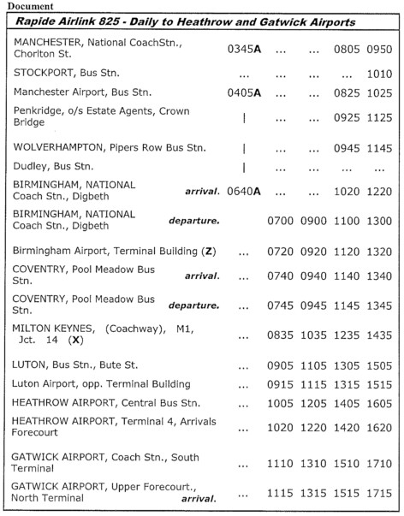

25- What would you like to learn in this class / in English? (Qu’est-ce que tu aimerais apprendre dans cette formation?)

----------------------------------------------------------------

----------------------------------------------------------------

----------------------------------------------------------------

----------------------------------------------------------------

----------------------------------------------------------------

